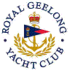 | Royal Geelong Yacht Club Inc.  Est 1859
Trophy Deed of Gift.

Trophy: | Winchester Western
Presented by: | Sir Vernon Christie:  Managing Director, Winchester Western
Date: | 1967
For: | Division II Aggregate  - Portarlington Race  - Channels Race  - Glover Cup  - Mornington Race  - Queenscliff Race.  2003-2004 Reallocated to Div. II Club Course Sub-Aggregate
Remarks / Revisions | Golden Anniversary Winchester 32 Rifle  (In working order)  The gun is kept under lock and key to comply with gun regulations.
2023 Update | The Mk 1 trophy was disposed of in about 2018 due to Gun Laws, and replaced with the Mk 2 Trophy (Photo Below).
Click here for a List of Recipients

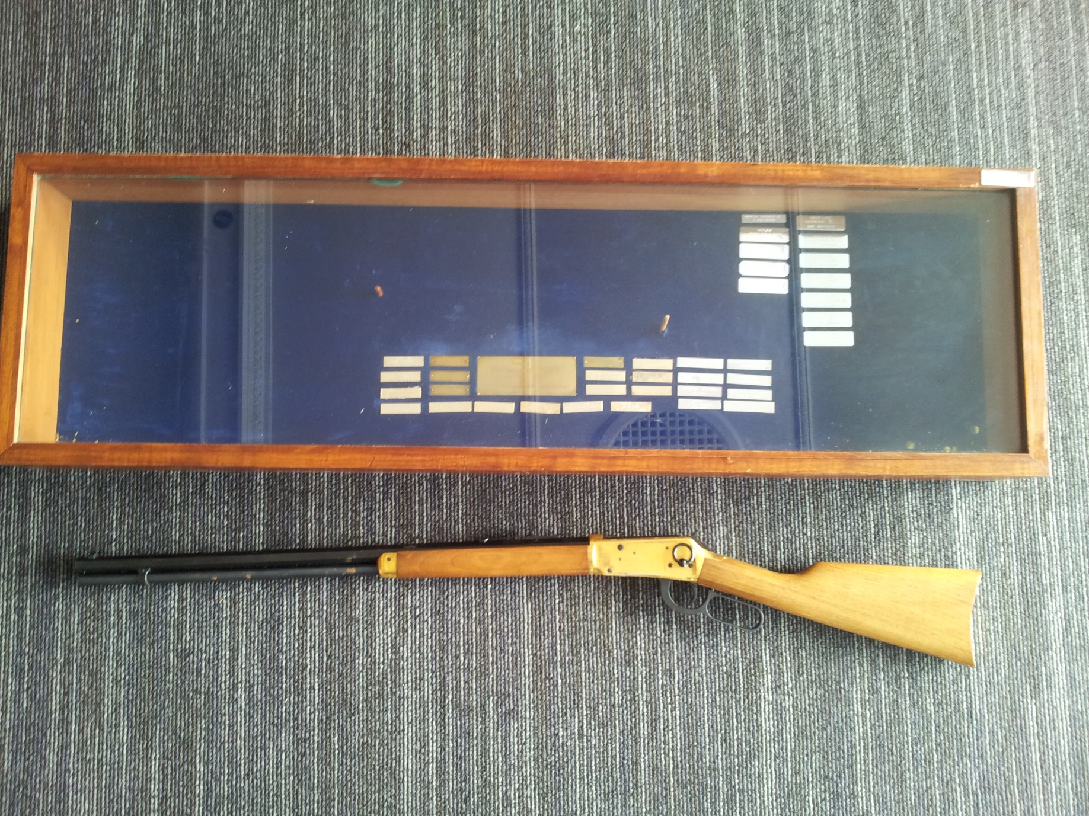
Winchester Trophy (Mk 1)

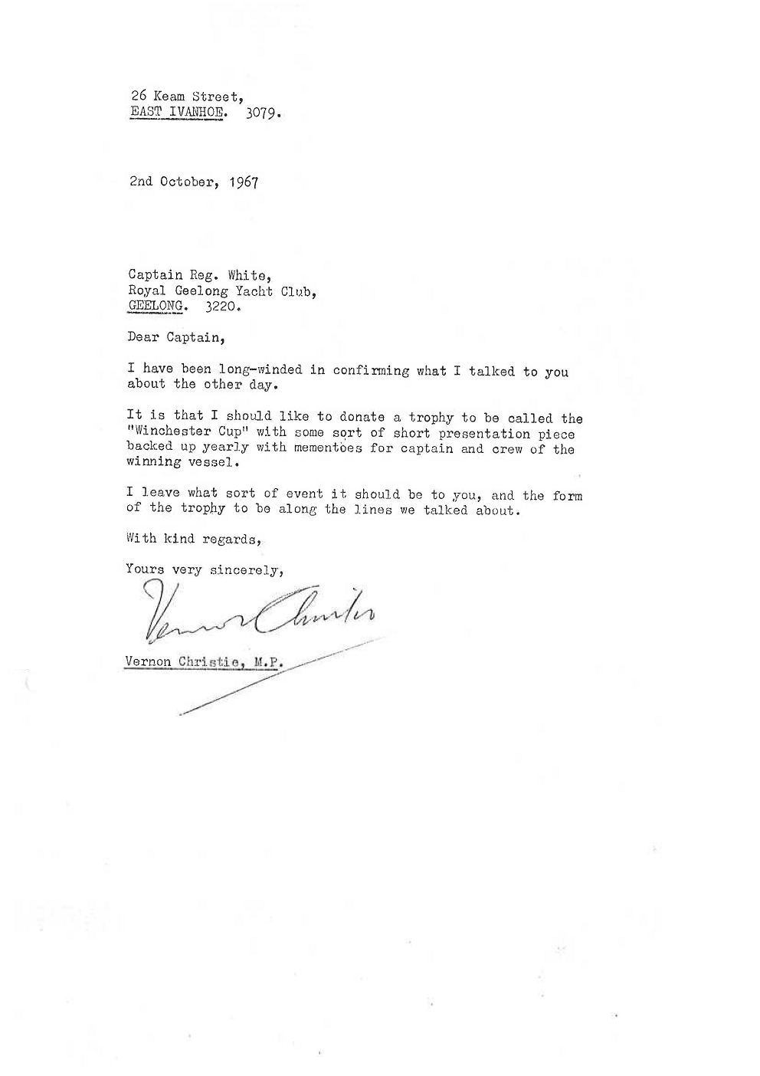

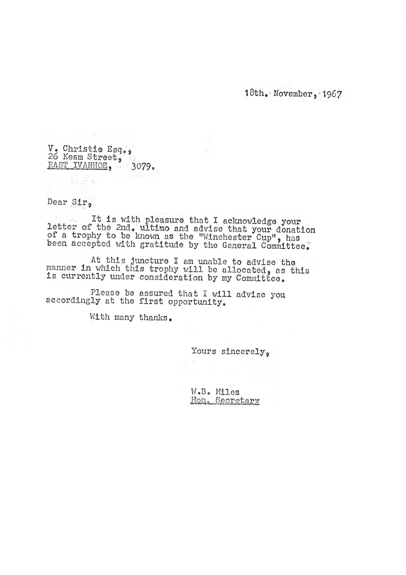

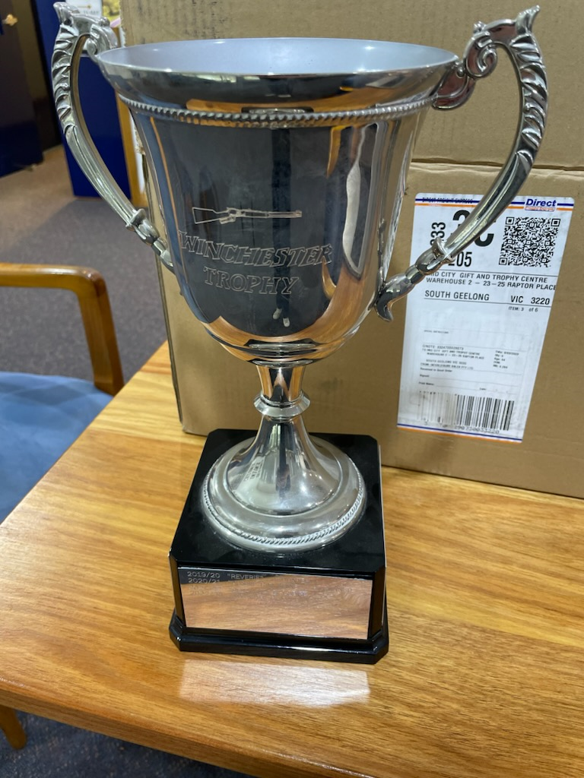
Winchester Trophy (Mk 2)

